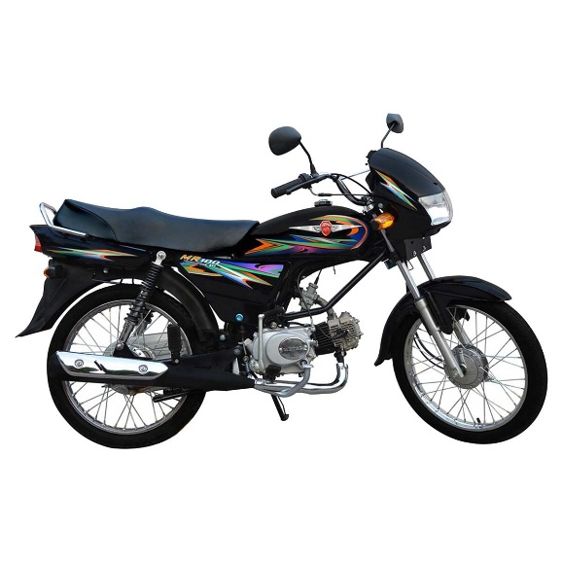

METRO 100cc Motorcycle - MR100 Red / Black Motorbike

Product details of METRO 100cc Motorcycle - MR100 Red / Black Motorbike

* Engine Type:Wet sump, Single Cylinder, Four Stroke, Two Valves, Air Cooled with SOHC (Single Over Head Cam) Chain Drive
* Bore & Stroke:50.0 x 49.5 MM
* Piston Displacement:97cc
* Compression Ratio:9:1
* Starting:Kick Starter
* Ignition:Capacitor Discharge Ignition (CDI)
* Chassis Type:Back Bone Type Iron Pipe Swing Arm
* Length*Width* Height:1915*820*1180 (mm)
* Wheel Base:1215mm

METRO 100cc Motorcycle - MR100 Red Motorbike (Lahore , Gujranwala , Sialkot , Islamabad , Karachi & Faisalabad Only)

|  |  |
| --- | --- |
| Engine Type: | Wet sump, Single Cylinder, Four Stroke, Two Valves, Air Cooled with SOHC (Single Over Head Cam) Chain Drive |
| Bore & Stroke | 50.0 x 49.5 MM |
| Piston Displacement | 97cc |
| Compression Ratio | 9:1 |
| Starting | Kick Starter |
| Ignition | Capacitor Discharge Ignition (CDI) |
| Transmission Type | Four Speed Constant Mesh (Multi disc wet type clutch) |
| Chassis Type | Back Bone Type Iron Pipe Swing Arm |
| Length*Width* Height | 1915*820*1180 (mm) |
| Wheel Base | 1215mm |
| Tyre Front | 2.50 18 4 PR |
| Tyre Rear | 2.50 18 4 PR |
| Ground Clearance | 135mm |
| Dry Weight | 87 kg |
| Fuel Tank (Capacity) | 9 Liters/1 Liter Reserve |
| Battery | 12V 3.5A |
|  |  |

|  |
| --- |
|  |

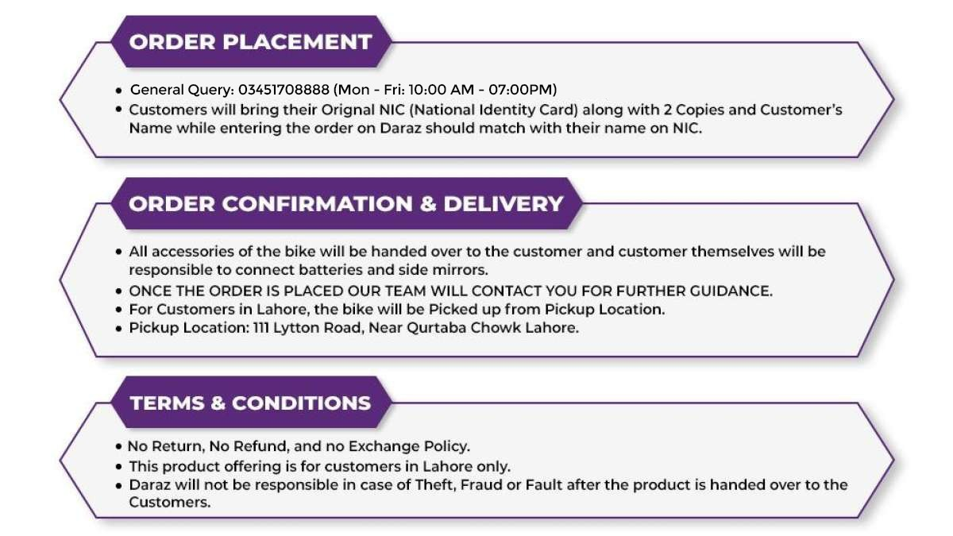

Specifications of METRO 100cc Motorcycle - MR100 Red / Black Motorbike

* Brand

Metro Motor Bikes

* SKU

134871556_PK-1295177110

* Engine displacement (cc)

100 CC

* Location

Lahore,Islamabad,Karachi,Gujranwala,Sialkot,Faisalabad

* Number of Cylinders

1

* Number of Gears

4

* Model Year

Model Year- 2022

* Services

product with services

* Model

2022

* Warranty Policy EN

6 Months or 6000 KMs

What’s in the box

1x MR100, 1x Complete Accessories